**Course Five**

# Regression Analysis: Simplifying Complex Data Relationships

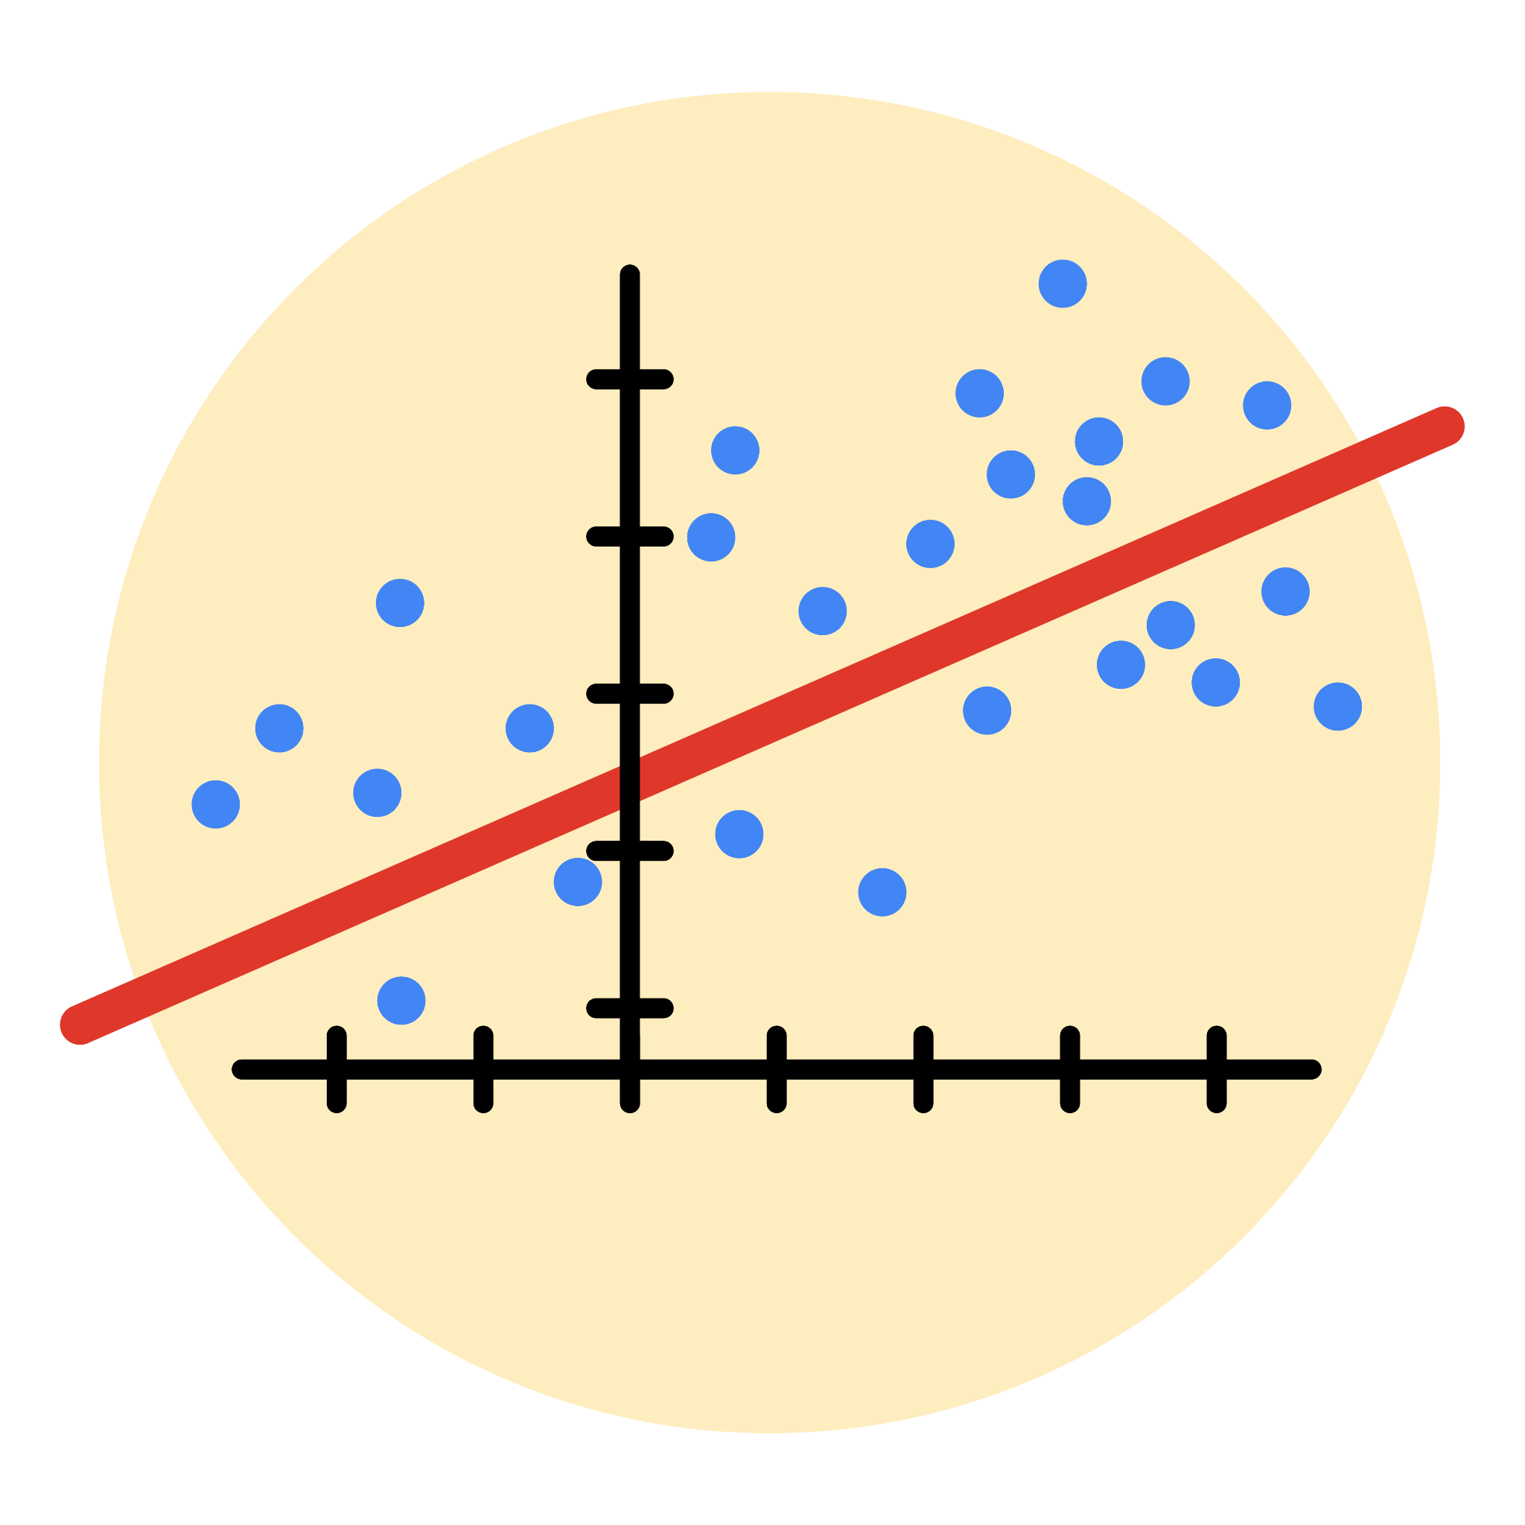

# Instructions

Use this PACE strategy document to record decisions and reflections as you work through this end-of-course project. As a reminder, this document is a resource that you can reference in the future, and a guide to help you consider responses and reflections posed at various points throughout projects.

# Course Project Recap

Regardless of which track you have chosen to complete, your goals for this project are:

* Complete the questions in the Course 5 PACE strategy document
* Answer the questions in the Jupyter notebook project file
* Build a multiple linear regression model
* Evaluate the model
* Create an executive summary for team members

# Relevant Interview Questions

Completing the end-of-course project will empower you to respond to the following interview topics:

* Describe the steps you would take to run a regression-based analysis
* List and describe the critical [assumptions of linear regression](https://www.digitalvidya.com/blog/assumptions-of-linear-regression/)
* What is the primary difference between R2 and adjusted R2?
* How do you interpret a Q-Q plot in a linear regression model?
* What is the bias-variance tradeoff? How does it relate to building a multiple linear regression model? Consider variable selection and adjusted R2.

**Reference Guide**

This project has seven tasks; the visual below identifies how the stages of PACE are incorporated across those tasks.

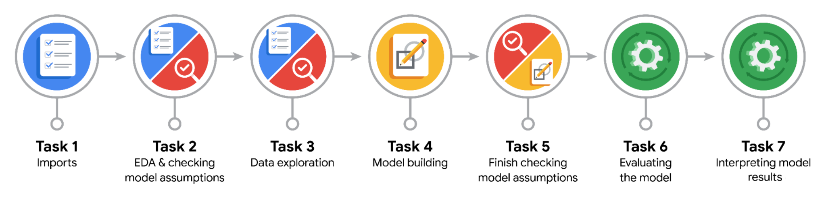

**Data Project Questions & Considerations**

**PACE: Plan Stage**

* Who are your external stakeholders for this project?
* What are you trying to solve or accomplish?
* What are your initial observations when you explore the data?
* What resources do you find yourself using as you complete this stage?

**PACE: Analyze Stage**

* What are some purposes of EDA before constructing a multiple linear regression model?
* Do you have any ethical considerations in this stage?

**PACE: Construct Stage**

* Do you notice anything odd?
* Can you improve it? Is there anything you would change about the model?
* What resources do you find yourself using as you complete this stage?

**PACE: Execute Stage**

* What key insights emerged from your model(s)?
* What business recommendations do you propose based on the models built?
* To interpret model results, why is it important to interpret the beta coefficients?
* What potential recommendations would you make?
* Do you think your model could be improved? Why or why not? How?
* What business/organizational recommendations would you propose based on the models built?
* Given what you know about the data and the models you were using, what other questions could you address for the team?
* Do you have any ethical considerations at this stage?